6 In-class exercises

Consider the following data, decision boundary, and margin boundaries.

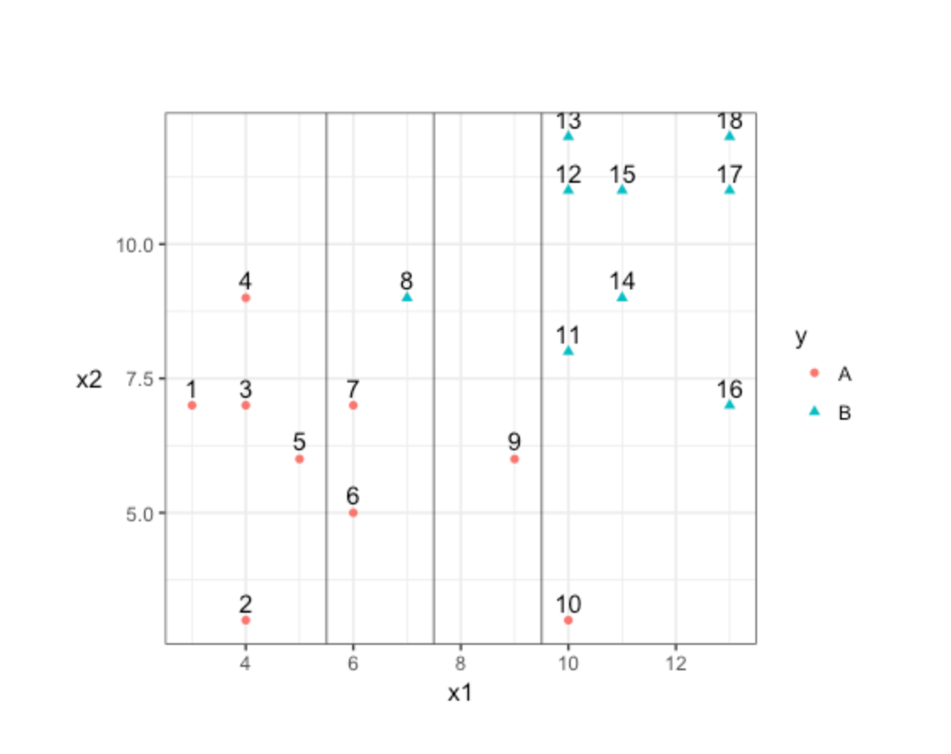

1. Construct the decision rule according to this classification boundary. How would you classify a new observation that has x1=6 and x2=10?

When X1<7.5, we will define it as A; when X1>7.5, we will define it as B.

We will classify X1=6 and X2=10 as category A.

1. What size is the margin here?

The margin equals 2 here.

1. Which observations receive a penalty? Which observations are the support vectors?

6,7, 8, 9 and 10 will receive a penalty. All these points are the support vectors.

1. What is the total penalty here?

0.25\*2+1.75+2.25+1.25=5.75 (Number of margins away)

1. Can I choose a bigger margin if my total allowable penalty is 6?

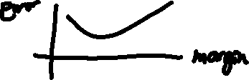

Yes. Since our current total penalty is smaller than 6. (Depends where we are)

1. Are the data separable? If so, what are the support vectors?

Yes. 4,8,9 are the support vectors. Or 4,8,11 will be the support vectors.